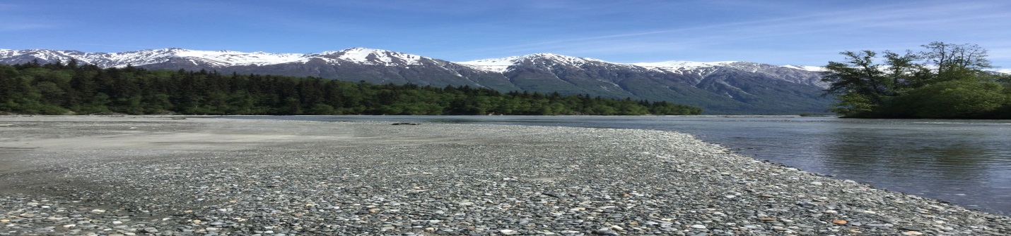
Save the date: May 1 – 3, 2017

Stream and Wetland Temperature Monitoring Training
&
Monitoring for Climate Change Training
For Tribes and Community Organizations
Hosted by Chilkat Indian Village
at
Klukwan, AK

For more information contact
Daniel Klanott, CIV Environmental Specialist
at 907-767-5505 ext. 224

Limited travel scholarships are available to attendees:
Contact Rebecca Bellmore, Southeast Alaska Watershed Coalition at (812) 603-4910 for more information on scholarships

In partnership with the Cook Inlet Keeper and the Southeast Alaska Watershed Coalition

