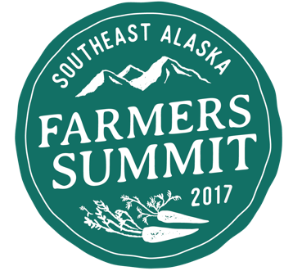

Scholarship Application
Please fill out the application below. Scholarship funds are limited, and will be awarded based on merit and need demonstrated. Scholarship amount will be based on anticipated travel expenses listed in the application. We will try to accommodate as many applicants as possible.
Applications will be accepted on a rolling basis, and will not be accepted after January 20, 2017. Scholarships will be issued as reimbursements after travel bookings have been made by recipient. Submit completed applications to Lia Heifetz, lia@growsoutheast.com, with “SAFS Scholarship” in the subject box.
Name:
Address:
Telephone:
Email:
Business or organization affiliation:

- Please describe why you wish to attend the Southeast Alaska Farmers Summit:

- What is the nature of your work (farmer, market manager, local foods advocacy, etc.)?

- What do you hope to get out of attending the Summit?

- How will you utilize the information disseminated at the summit to support or advance your goals for the next year?

- Please list or attach the anticipated itinerary and total cost of travel for which you are seeking scholarship funds. Include flight numbers, ferry sailings, and proposed dates of travel.

